SOLUTION ARCHITECTURE
PROJECT ID: PNT2022TMID47645

DOMAIN: IoT
Project Title: Smart Farmer – IOT Enabled SmartFarming Application

Team Leader:
L.VINOTH KUMAR

Team Members:

1.S.DINESH
2.PL.GOMATHI
3.DANIEL
4.SELVARAJ

SMART FARMER-IOT ENABLED SMART
FARMING APPLICATION

The proposed solution will assist farmers by getting live data (Temperature, humidity, soil moisture) from the farmland to take necessary steps to enable them to do smart farming by also increasing their crop yields and saving resources (water, fertilizers).

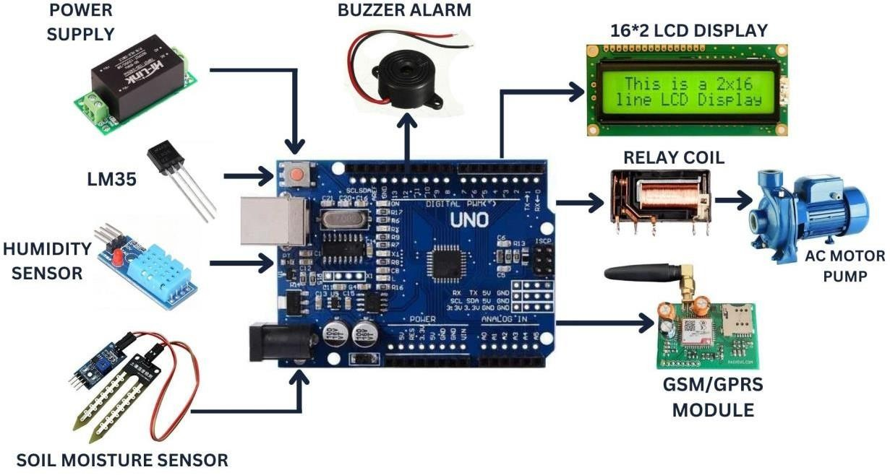

The architecture of proposed system consists of various blocks:

SENSORS

The soil moisture sensor senses the moisture level in the soil. The humidity and temperature sensor gives the humidity and temperature values of the atmosphere which determine whether the crop is suitable for growth. The soil moisture sensor, humidity and temperature sensor continuously monitors the soil and environmental conditions, sends the live data to mobile.

ARDUINO UNO

Arduino Uno is the heart of the system. The facts gathered with the aid of the sensors is sent to the Arduino UNO.The gathered information may be displayed in a Arduino IDE.
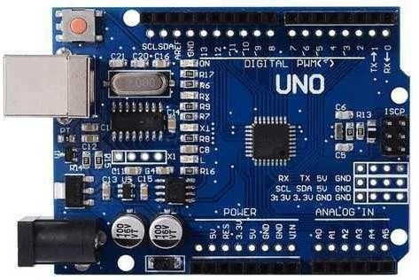

SOIL MOISTURE SENSOR

A soil moisture sensor empowers agriculturalists to estimate the water levels without the need to be physically present in the field.

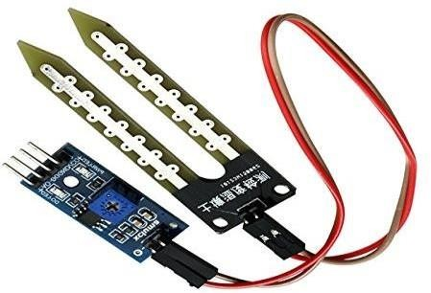

TEMPERATURE SENSOR

The temperature sensor senses the surrounding temperature of the farm in different farm conditions.

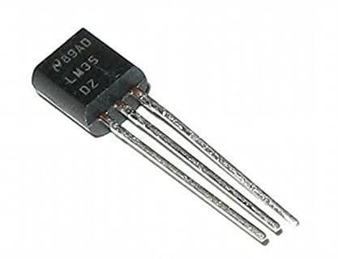

HUMIDITY SENSOR

Humidity sensors are electronic devices that measure and report the moisture and air temperature of the surrounding environment.

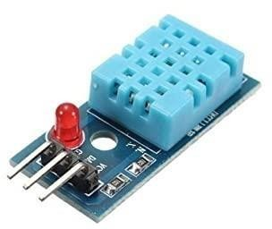

BUZZER ALARM

The project system can capture the image. This is to ward off the animals from fields. An buzzer is introduced, Its loudly audible to animals.

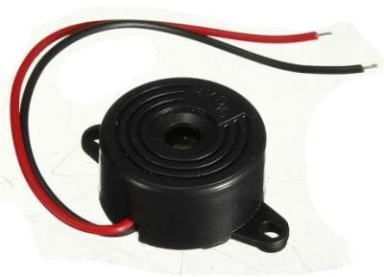

AC MOTOR PUMP

This pump will pump water from well and water is sent to the field.

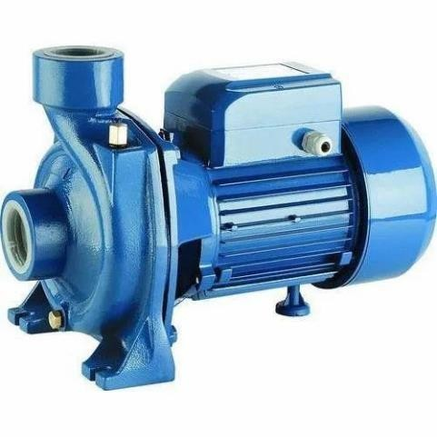

16*2 LCD DISPLAY

A LCD display is used to display the functioning of the project at any given time.
